

**Requirement & Design Specification**

**Smartphone Online Shop**

*GROUP 3-SWP391*

***Team members:***

*Nguyễn Nam Khánh-HE180034*

*Phan Minh Hiển-HE180216*

*Dương Thành Long-HE140916*

*Trương Quang Tâm-HE181412*

**Hanoi, May 2024**

1. INTRODUCTION AND TARGET

In today's digital age, online shopping is not only a trend but also a convenient and effective way to shop for both individuals and small businesses. The small-scale online shopping system we introduce is to help small businesses access the online market easily and cost-effectively.

With this system, small businesses can easily create and manage their online stores, bringing their products to customers quickly and conveniently. Using features such as order management, secure payments and a user-friendly interface, the system helps create a trustworthy online shopping experience for both sellers and buyers.

In this section, we will introduce the important non-functional requirements of a small-scale online shopping system, including user interface, performance, security, and documentation. This helps ensure that the system meets basic requirements and brings the highest value to users.

1. OVERVIEW
2. User Requirements
3. Actors

| **STT** | **Actor** | **Description** |
| --- | --- | --- |
| 1 | Admin | * Can manage all information of users in the system. * Can assign roles for employees. For example: administrator, managers... |
| 2 | Guest | * Can register on the web. * Can view homepage. * Can view remarkable products. * Can view categories.. * Can view product details. * Can search products with filters (name, brand, low-high price, high-low price, chip, RAM, ROM, screen ) . |
| 3 | User | * Can log in/ log out (remember, reset password). * Edit profile(change password, update information). * Can manage products (add, delete, edit) on cart. * Can order on the web, view order history. |
| 4 | Manager | * Can manage order details (view order list by date). * Can view customers who order. * Can manage products and product details. * Can manage categories and category details. |

1. Use Cases

* Diagram

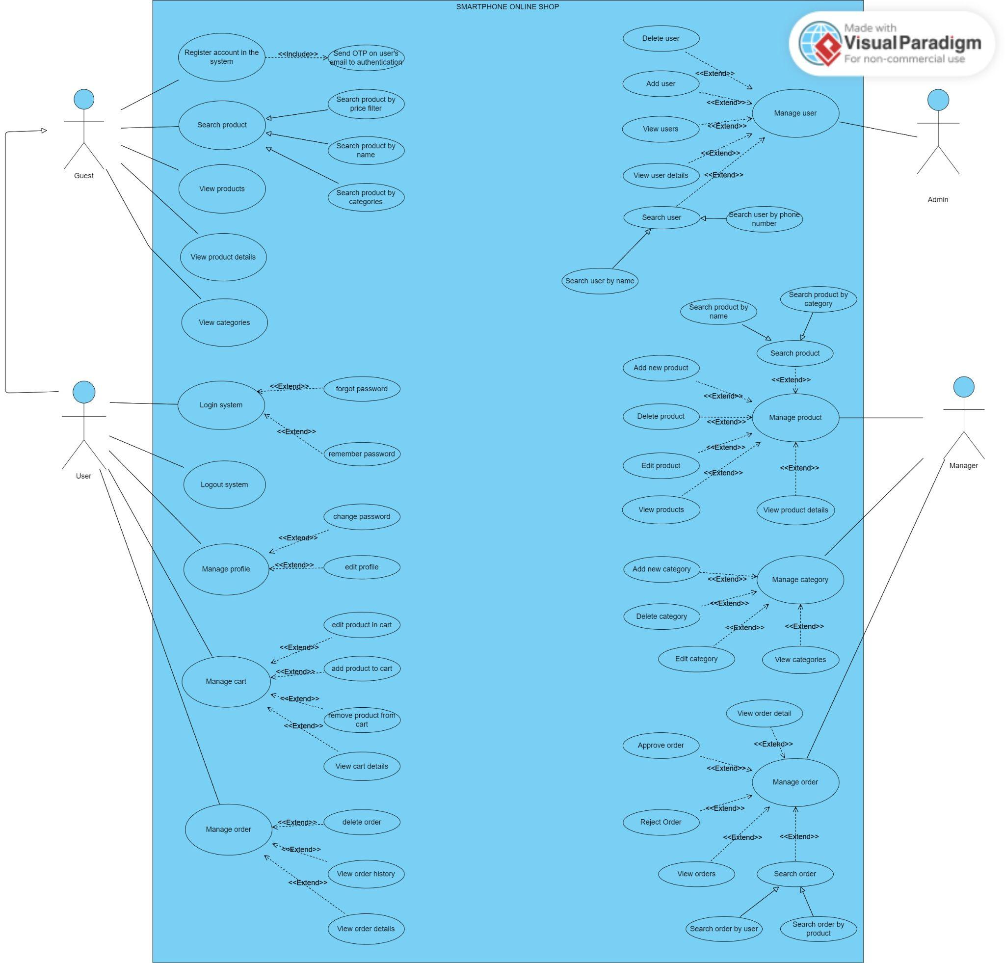

* Description of use cases

| **ID** | **Actor** | **Feature** | **Use Case** | **Use Case Description** |
| --- | --- | --- | --- | --- |
| 01 | Guest | Register account | Send OTP to user’s email | To be able to verify that this is the user's email or not. |
| 02 | Guest | View products | View products | Can view products in the store. |
| 03 | Guest | View product details | View product details | Can view product details of any product in the store so they can make their choice of other products. |
| 04 | Guest | Search product | Search product by price filter | Can search for the products they want by using price filters. |
| 05 | Guest | Search product | Search product by name filter | Can search the products that they want by using name filters. |
| 06 | Guest | Search product | Search product by categories and properties filter | Can search the products that they want using categories and properties filters. |
| 07 | Guest | View categories | View categories | Can view categories in the store. |
| 08 | Admin | Manage user | View user details | Can view all users in a list to manage. |
| 09 | Admin | Manage user | View users | Can view overall users. |
| 10 | Admin | Manage user | Add user | Can create an account for new users. |
| 11 | Admin | Manage user | Delete user | Can delete an account of a user. |
| 12 | Admin | Manage user | Search user | Can search by name or phone number that helps Admin find out rapidly users. |
| 13 | User | Login | Forgot password | Can reset password if the user forgot that. |
| 14 | User | Login | Remember password | Can remember passwords so user can login conveniently for after login |
| 15 | User | Logout | Logout | Can log out to change an account or secure account. |
| 16 | User | Manage profile | Change password | Can change passwords that help users simply manage their account. |
| 17 | User | Manage profile | Edit profile | Can update information of users such as email, name, address. |
| 18 | User | Manage cart | Add to cart | Can add products that the user wants to buy. |
| 19 | User | Manage cart | Remove product from cart | Can remove products if the user does not want to buy this product. |
| 20 | User | Manage cart | Edit product in cart | Can update the quantity of each product. |
| 21 | User | Manage cart | View cart details | Can view detailed products that users add to cart. |
| 22 | User | Manage order | Delete order | Can delete orders when users want to order other products. |
| 23 | User | Manage order | View order history | Can check the history of each order. |
| 24 | User | Manage order | View order details | Can view order details for easy management. |
| 25 | Manager | Manage product | Add new product | Can add a new product to the shop. |
| 26 | Manager | Manage product | Delete product | Can delete an existing product from the shop. |
| 27 | Manager | Manage product | Edit product | Can edit an existing product information. |
| 28 | Manager | Manage product | View products | Can view products in the store. |
| 29 | Manager | Manage product | View product details | Can view product details of any product in the store. |
| 30 | Manager | Manage product | Search Product | Can search products by name, category, properties |
| 31 | Manager | Manage category | Add new category | Can add a new category in the system. |
| 32 | Manager | Manage category | Delete category | Can delete an existing category from the shop. |
| 33 | Manager | Manage category | Edit category | Can edit an existing category information. |
| 34 | Manager | Manage category | View categories | Can view categories in the store. |
| 35 | Manager | Manage order | View orders | Can view the user's orders. |
| 36 | Manager | Manage order | View order details | Can view details of each user’s order. |
| 37 | Manager | Manage order | Approve order | Approve customer’s orders. |
| 38 | Manager | Manage order | Reject order | Reject customer’s orders. |
| 39 | Manager | Manage order | Search order | Can search order by user or product. |

1. OVERALL FUNCTIONALITIES
2. **Screen Flow**
3. **Admin**

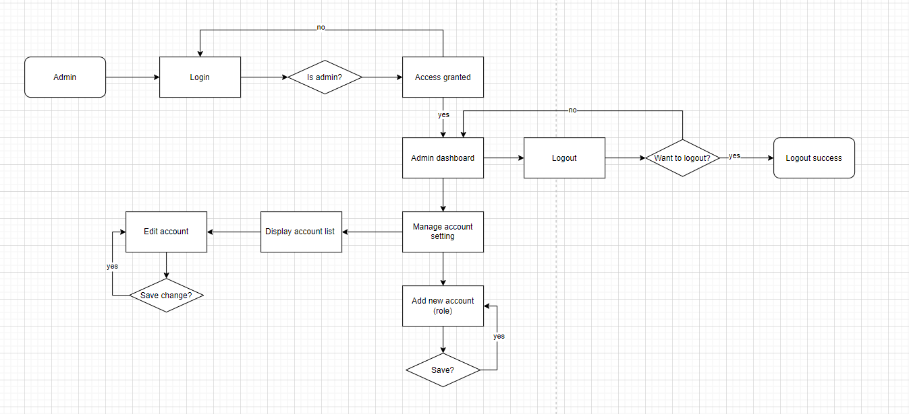

1. **Manager**

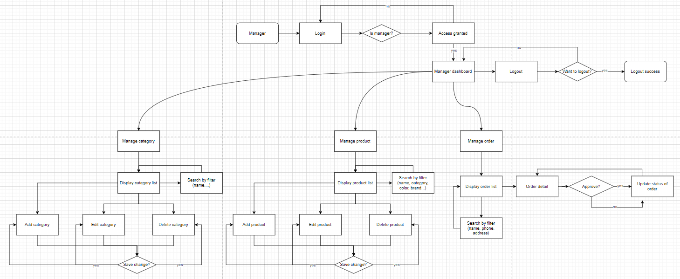

1. **User/Guest**

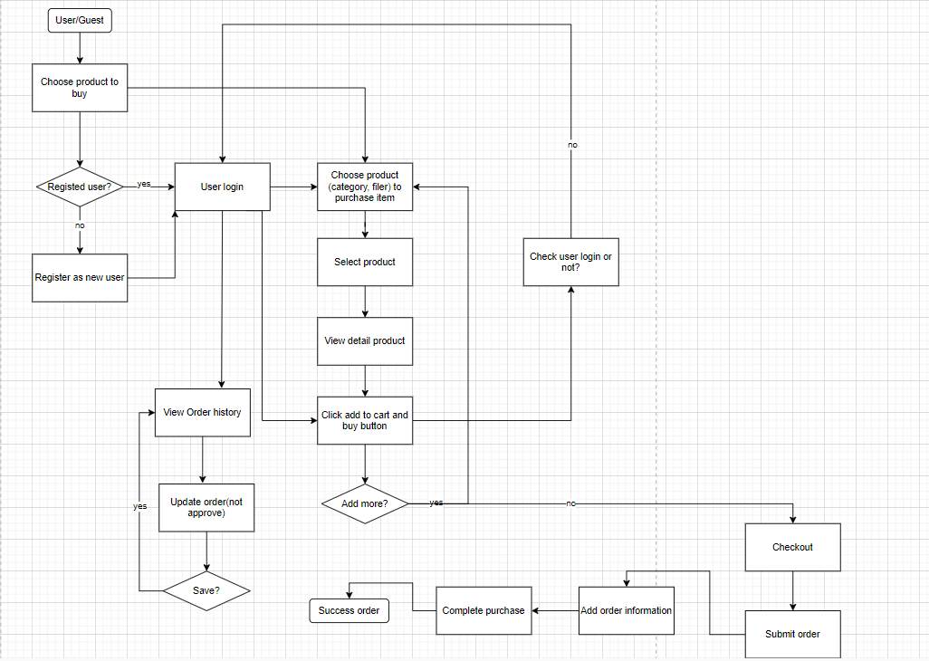

1. SYSTEM HIGH LEVEL DESIGN
2. **Database Design**

* Database Schema

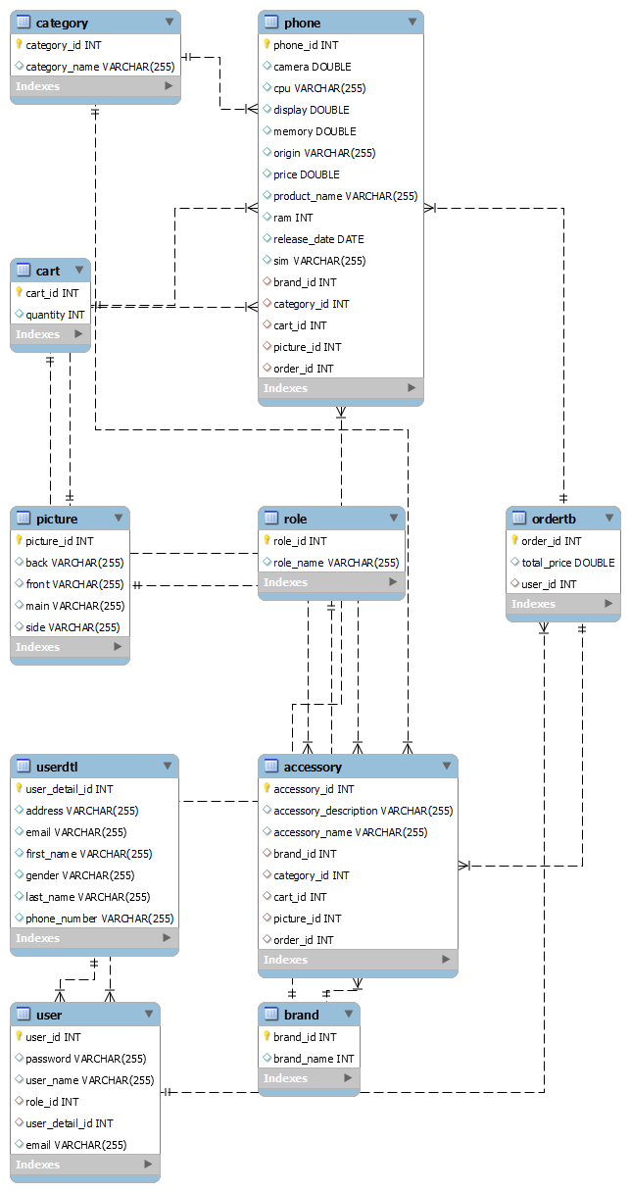

* Table Descriptions

| No | Table | Description |
| --- | --- | --- |
| 01 | user | Contains all users in the system. |
| 02 | userdtl | Contains user information of the user . |
| 03 | role | Contains roles in the system. |
| 04 | category | Contains categories in the system. |
| 05 | picture | Contains pictures of products in the system. |
| 06 | brand | Contains brand of product in the system. |
| 07 | ordertb | Contains all orders of users in the system. |
| 08 | phone | Contains phone information in the system. |
| 09 | accessory | Contains all accessory products in the system. |
| 10 | cart | Contains all cart items in the user’s cart. |

1. **Code packages**

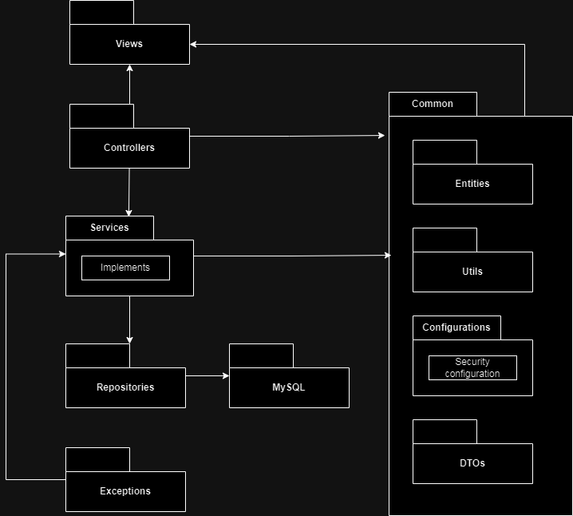

* **Package descriptions**

| No | Package | Description |
| --- | --- | --- |
| 01 | **Views** | **Top layer of spring boot, consist of views like HTML, the frontend part of application** |
| 01 | **Controllers** | **This package will receive request and response for client or redirect on application** |
| 02 | **Services** | **The business layer contains all the business logic. It consists of service classes. It is responsible for validation and authorization.** |
| 03 | **Repositories** | **The repositories package contains all the database storage logic. It is responsible for converting business objects to the database row** |
| 04 | **MySQL** | **Using MySQL** |
| 05 | **Exceptions** | **This package contains all exceptions that could be cause on application** |
| 06 | **Entities** | **This package contains all entities mapping with table on database** |
| 07 | **Utils** | **This package contains validate methods, convert methods, …** |
| 08 | **Configurations** | **This package contains all configuration of the application consisting of security configuration,...** |
| 09 | **DTOs** | **This package contains all data transfer object** |

1. WORK OF EACH MEMBERS

Link: [Project tracking.xlsx](https://docs.google.com/spreadsheets/d/1oeOno42itGLfowyWpKvXn3oIdVtdR71F/edit#gid=104203106)

1. SYSTEM REQUIREMENTS

**Functional Requirements**

1. **Public Feature**

Displayed for guests and users to use in the system, with functions such as:

* Home Page: Is the homepage of the website, showing general information and product overview on the page.
* Product List: list of products displayed. Can add, delete, edit or search products by filter.
* Product Details: Detailed information of the product
* Category List: list of categories displayed. Can add, delete, edit or search products by category.
* Category Detail: See all description of category.

1. **Common Feature**

Applicable to users in the system.

* User Login: Verify user login, optionally forgot password.
* User Register: Verify registration for new registrants, authenticate by email.
* Reset/Change Password: Reset the password while using that account in the system. You will need to authenticate with the user's email if you want to change.
* User Authorization: Deploy authorization on the system based on their ID in the data.

1. **User Feature**

Applicable to users in the system on screen.

* Cart Details: Information about the user's cart added, edited or deleted.
* Cart Contact: Shows and allows users to fill in information, edit and confirm application submission.
* Cart Completion: Order status completed/ Sent.
* My Orders: Shows customers the list of products they have ordered.
* Order Information: Displays the customer's order information, they can cancel or change the order when the order is still in submission status and has not been accepted by the admin.

1. **Manager**

Applicable to Sales person in the system on screen.

* Orders list/ details: Displays list/ detailed information of orders, can add, edit or delete options. Can search orders by filter.
* Add, edit, delete product into system (name, description, image, stock quantity,...)
* Manage category of each product (id, name).

1. **Admin Feature**

Applicable to Admin in the system on screen.

* Users list/ details: Displays the list/ detailed information of users logged in on the system, can add, edit and delete options.Can search users by filter.

**Non-Functional Requirements**

* User Interface: This includes aspects like ease of use, accessibility, responsiveness, and aesthetics.
* Performance: The system should perform under different conditions, such as expected response times, throughput, scalability, and resource utilization.
* Security: Include measures such as encryption standards for password,confirm OTP, authentication and authorization processes.
* Documentation and training: This encompasses the quality and availability of documentation, as well as any training materials or resources provided to users, administrators, and developers.

1. USER INTERFACE
2. **About us**

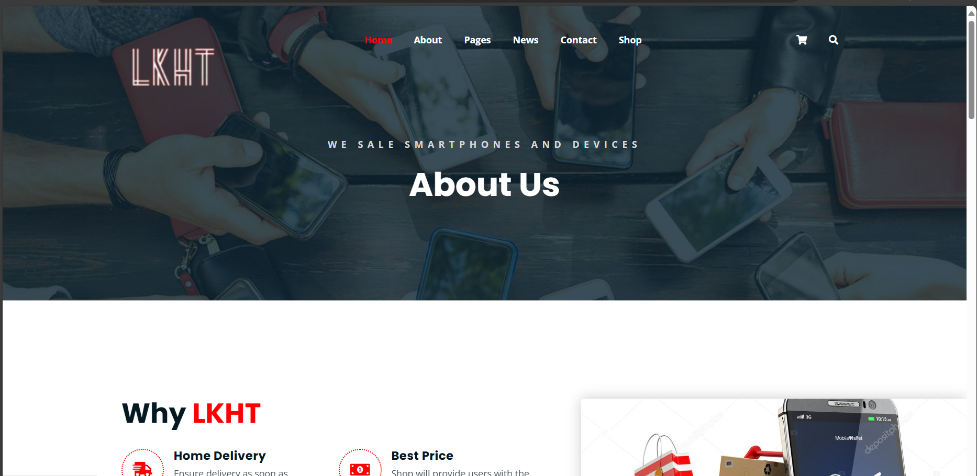

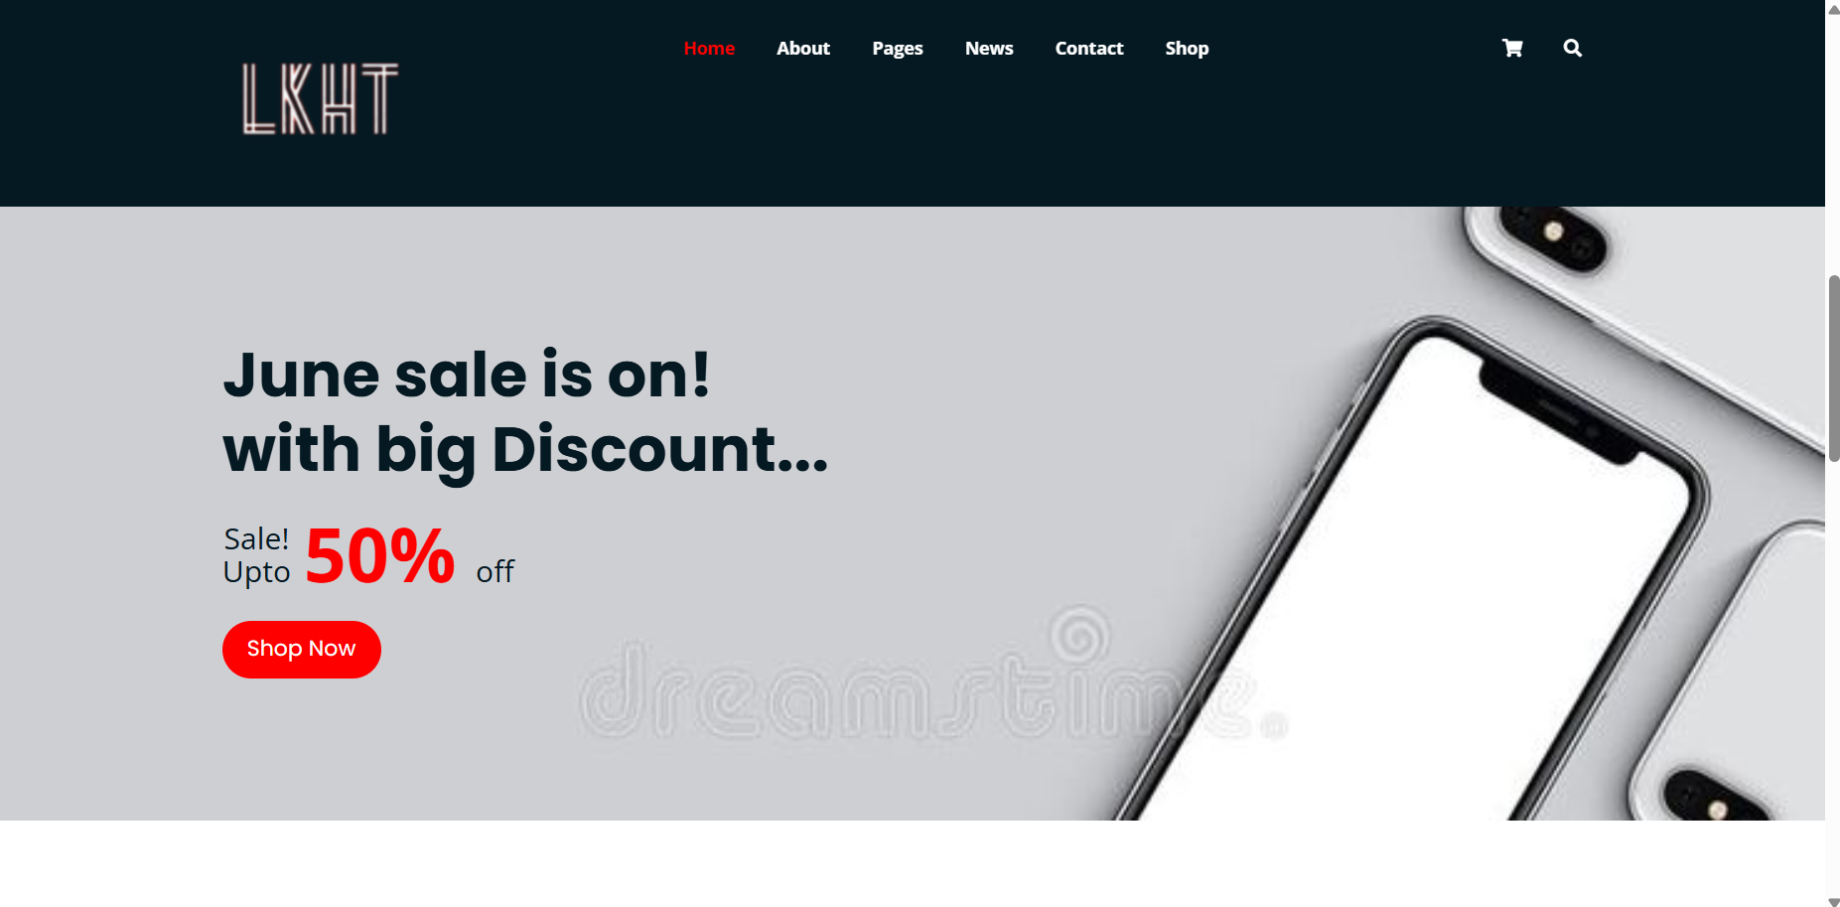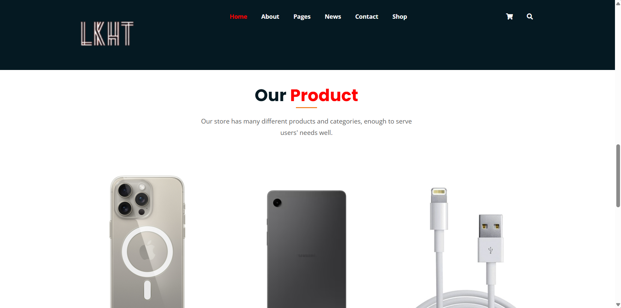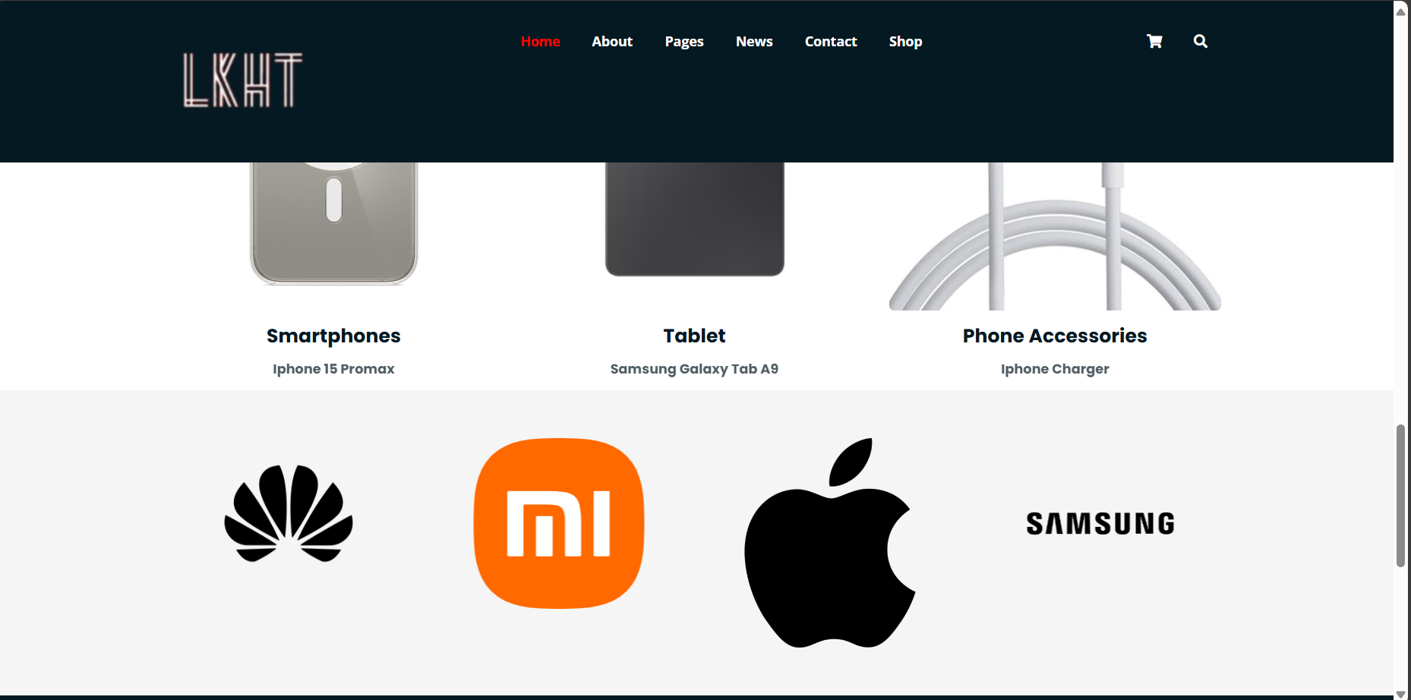

1. **Checkout**

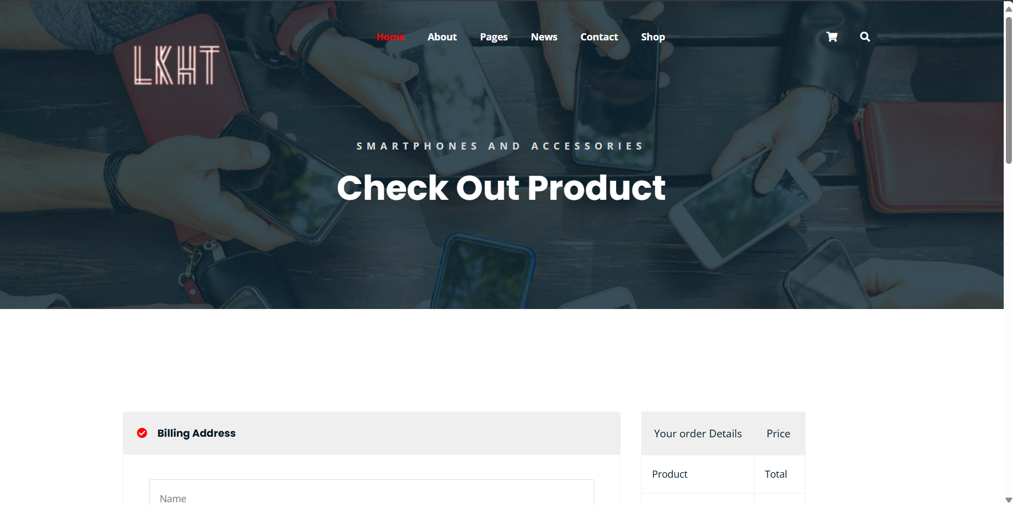

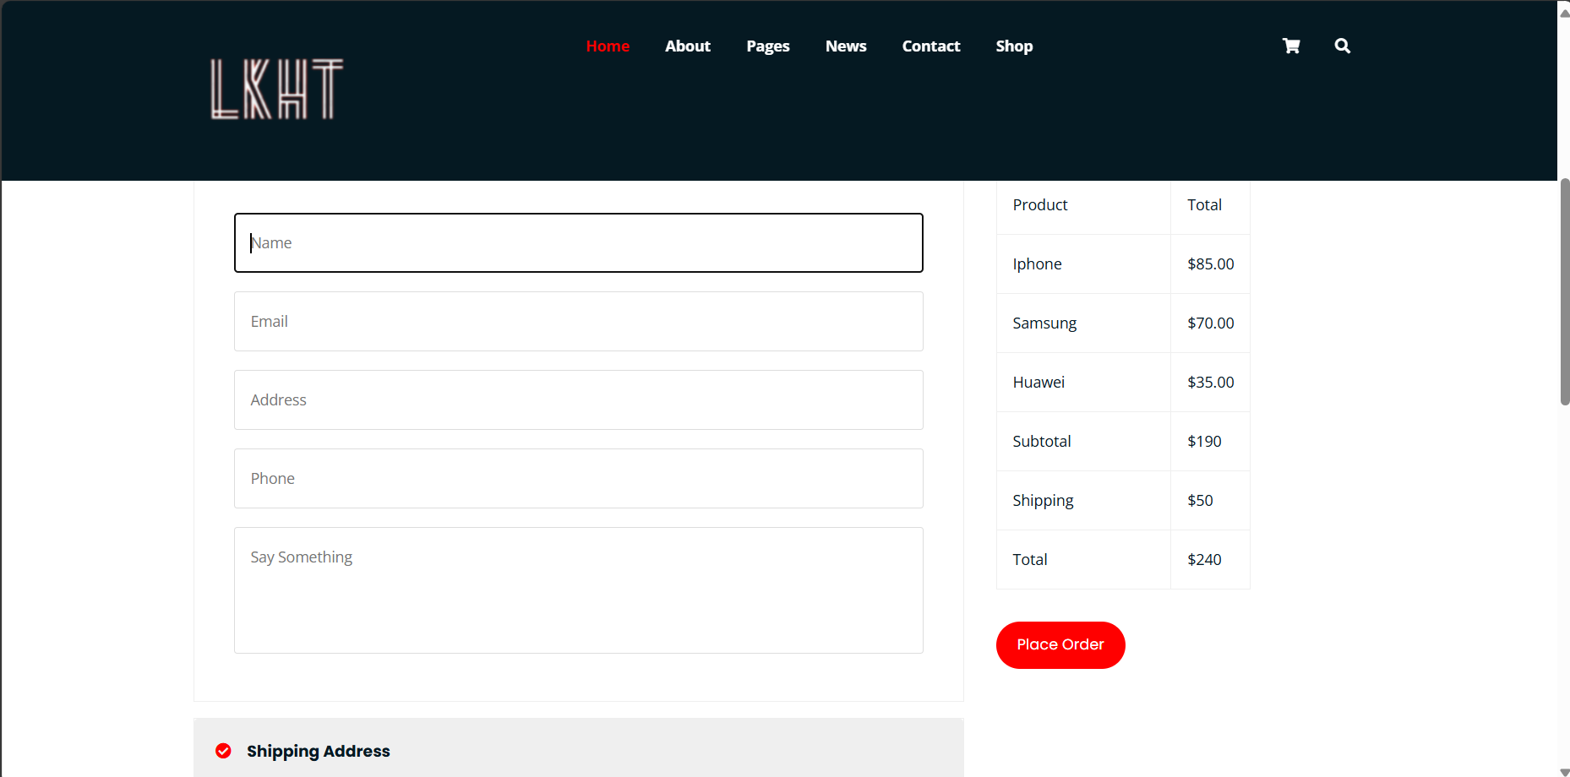

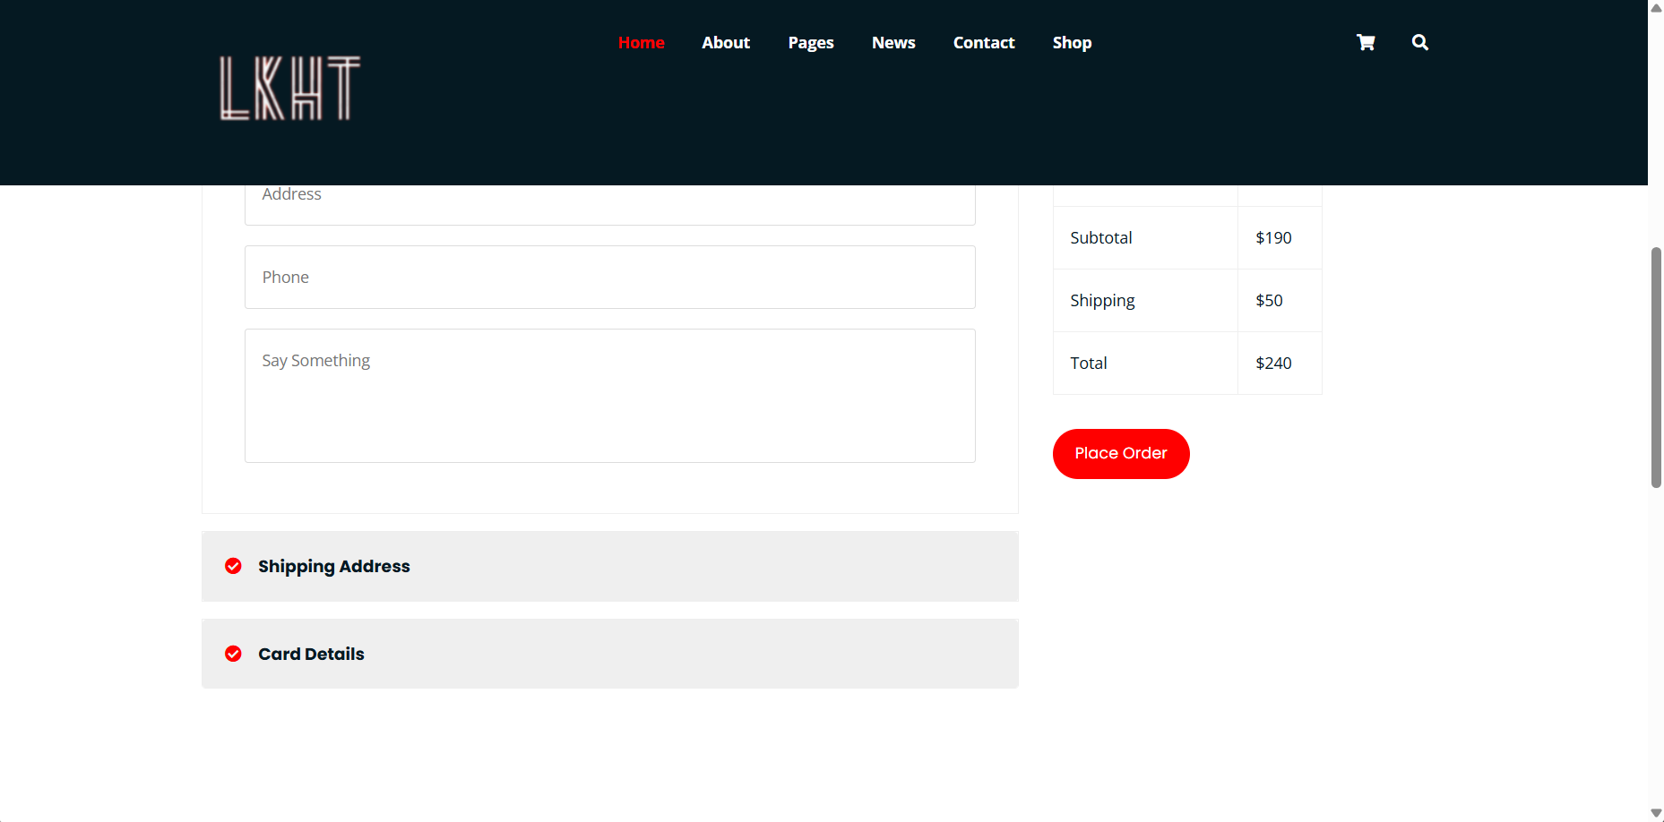

1. **Cart**

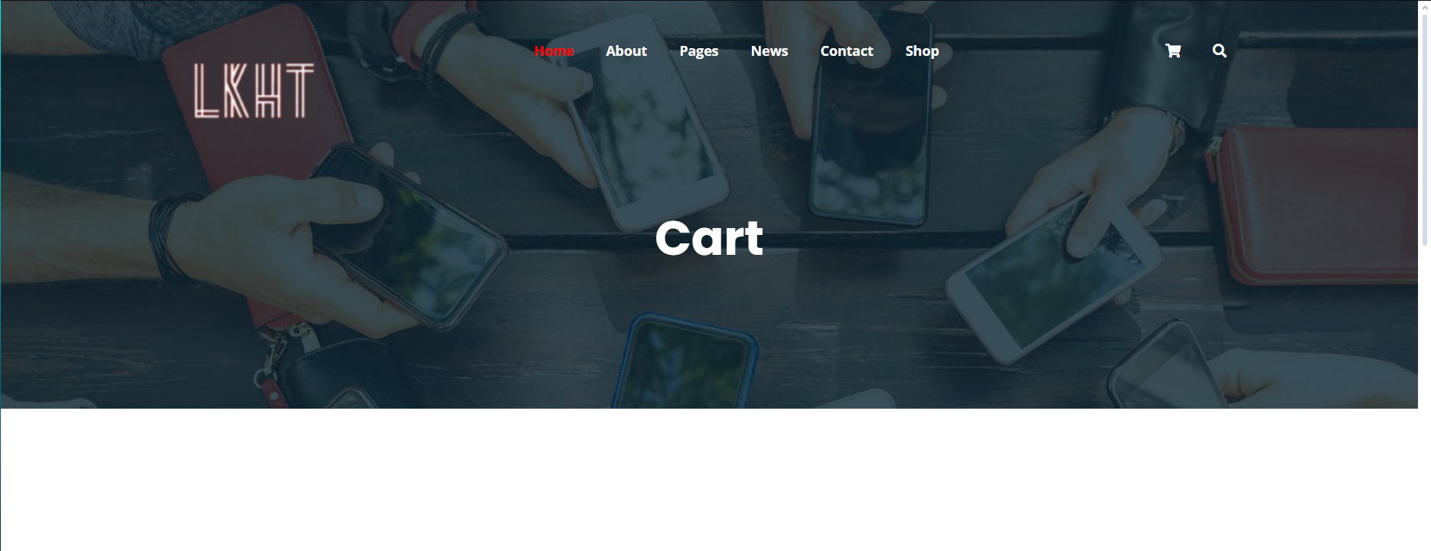

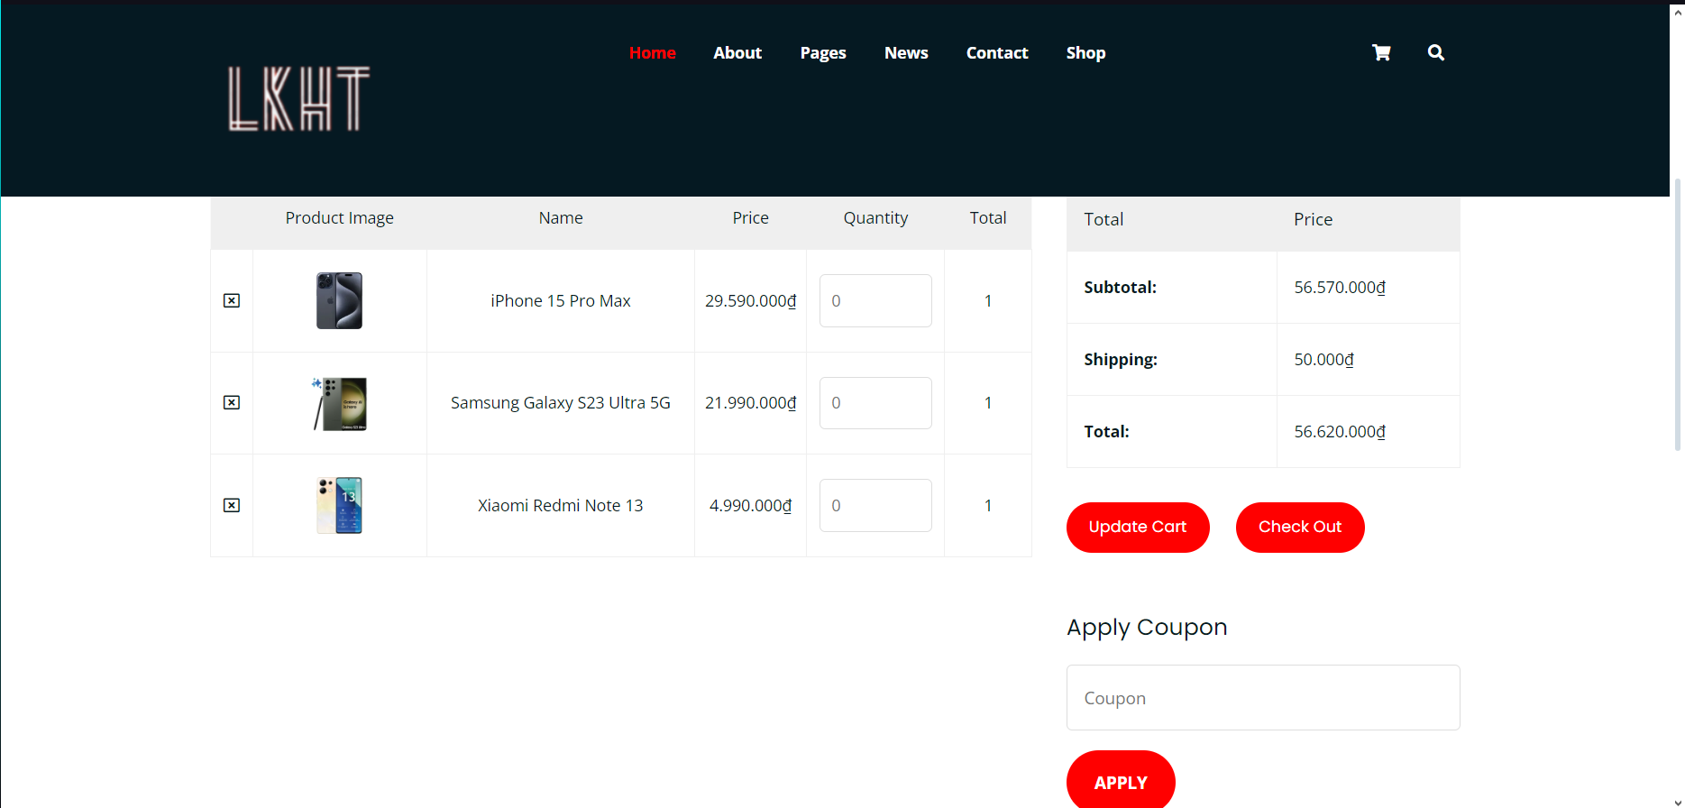

1. **Home**

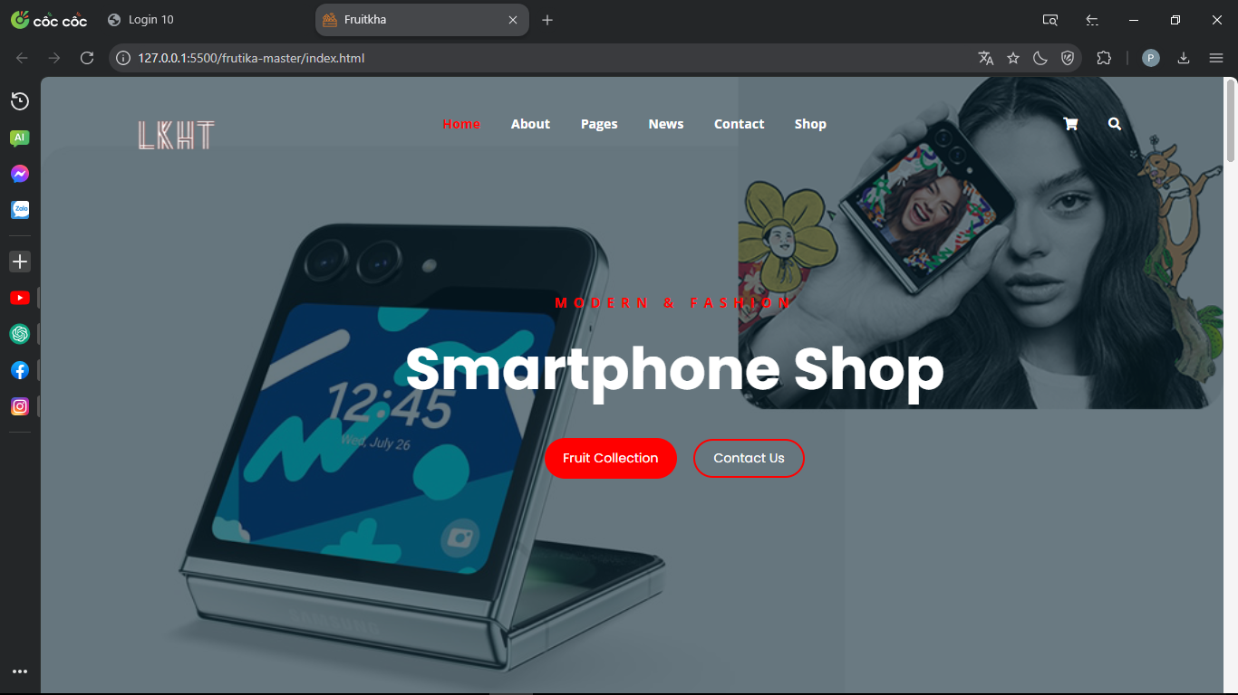

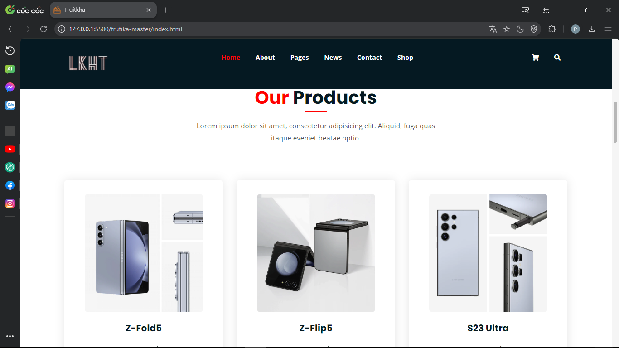

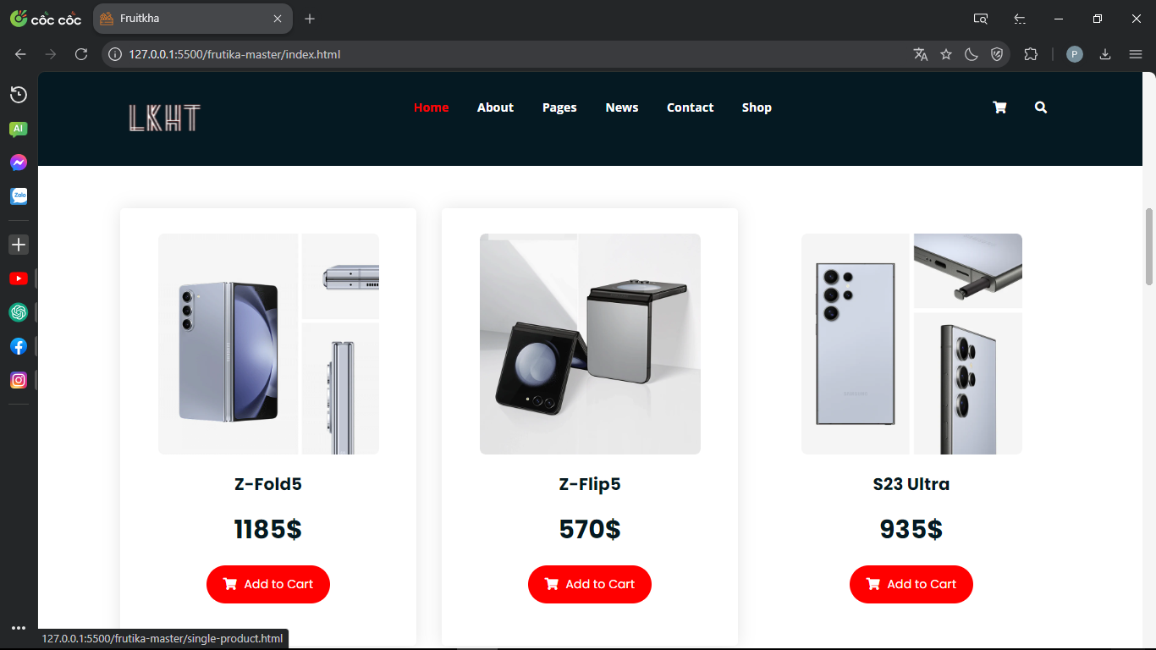

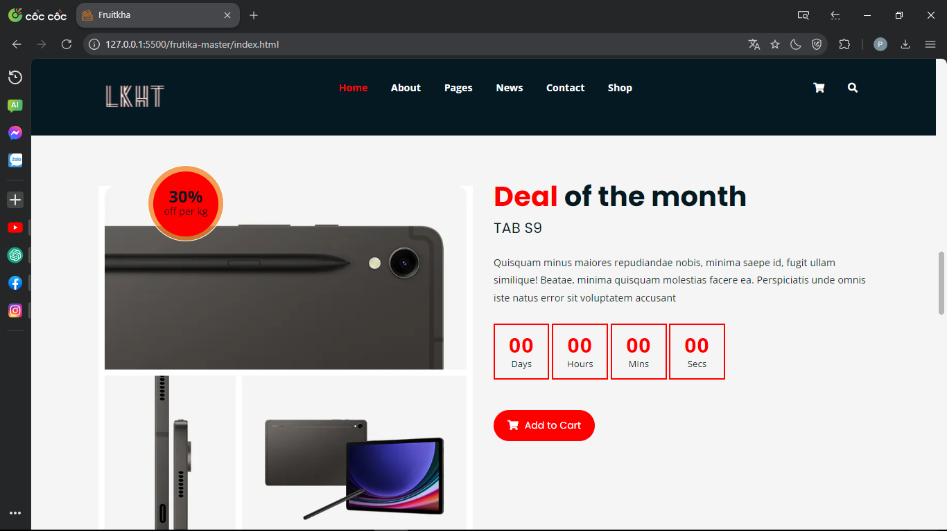

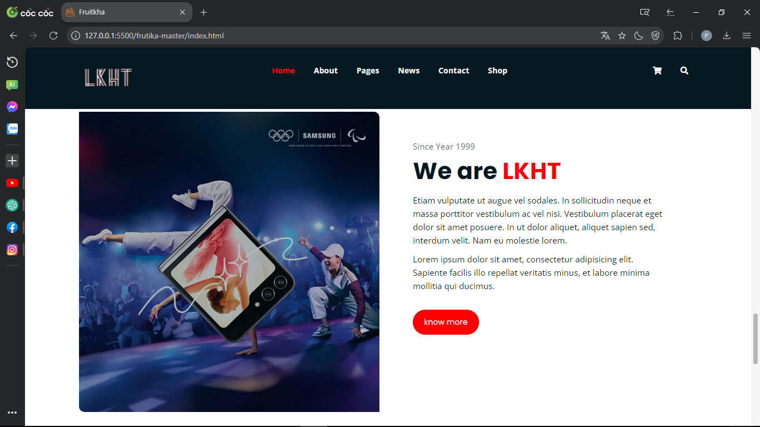

1. **Single product**

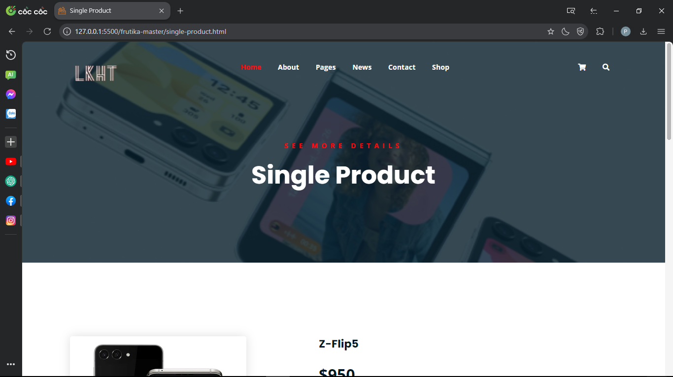

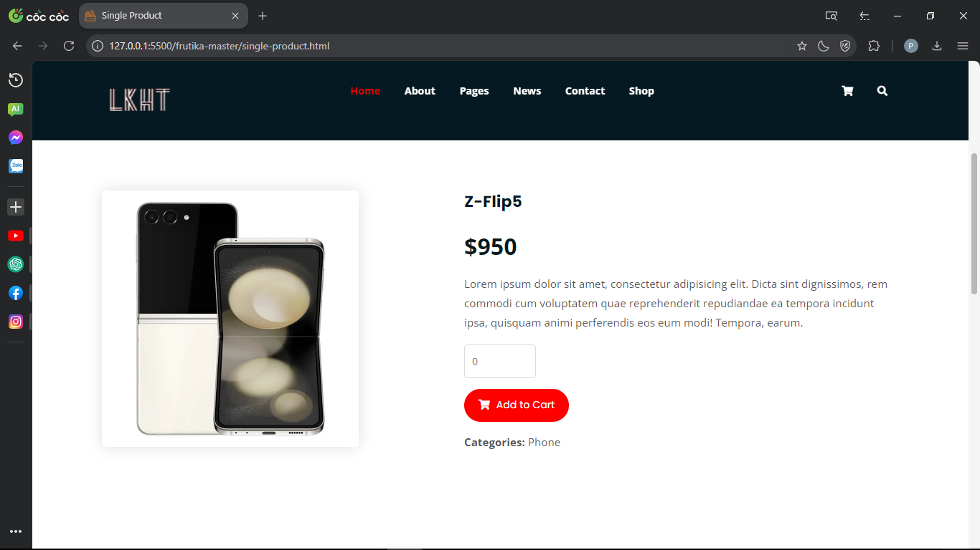

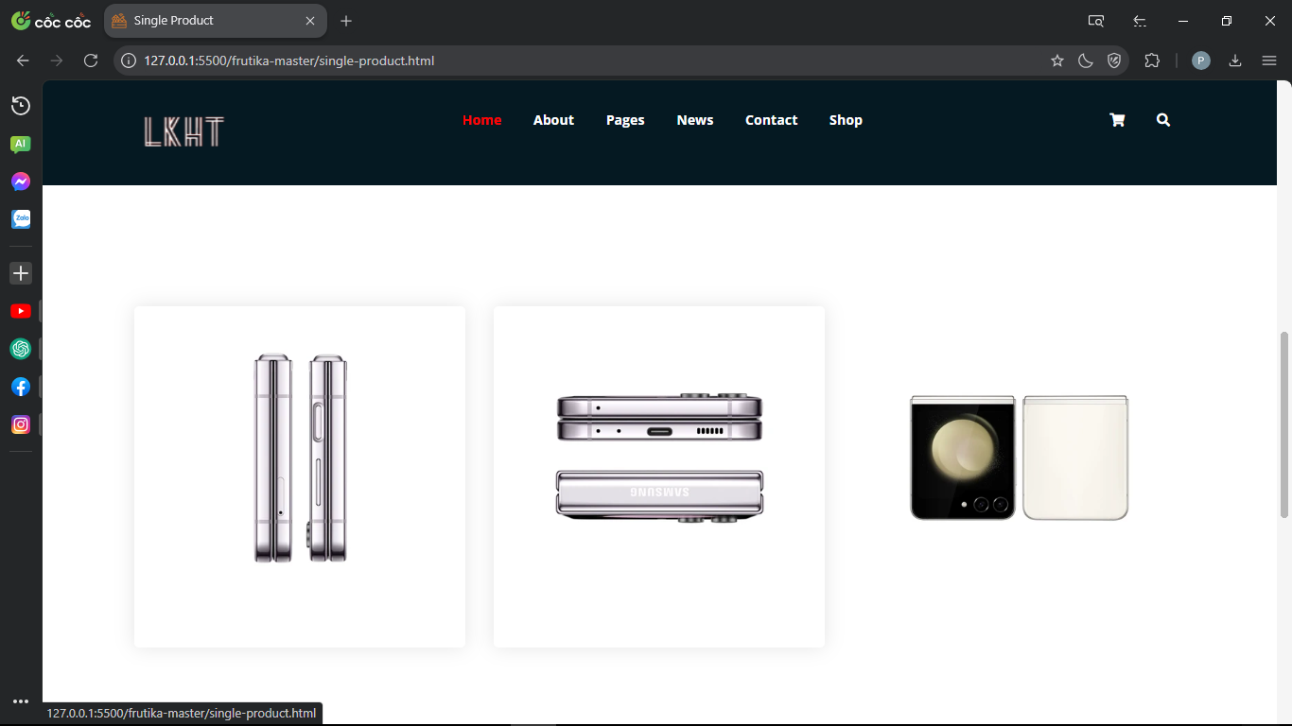

1. **Footer**

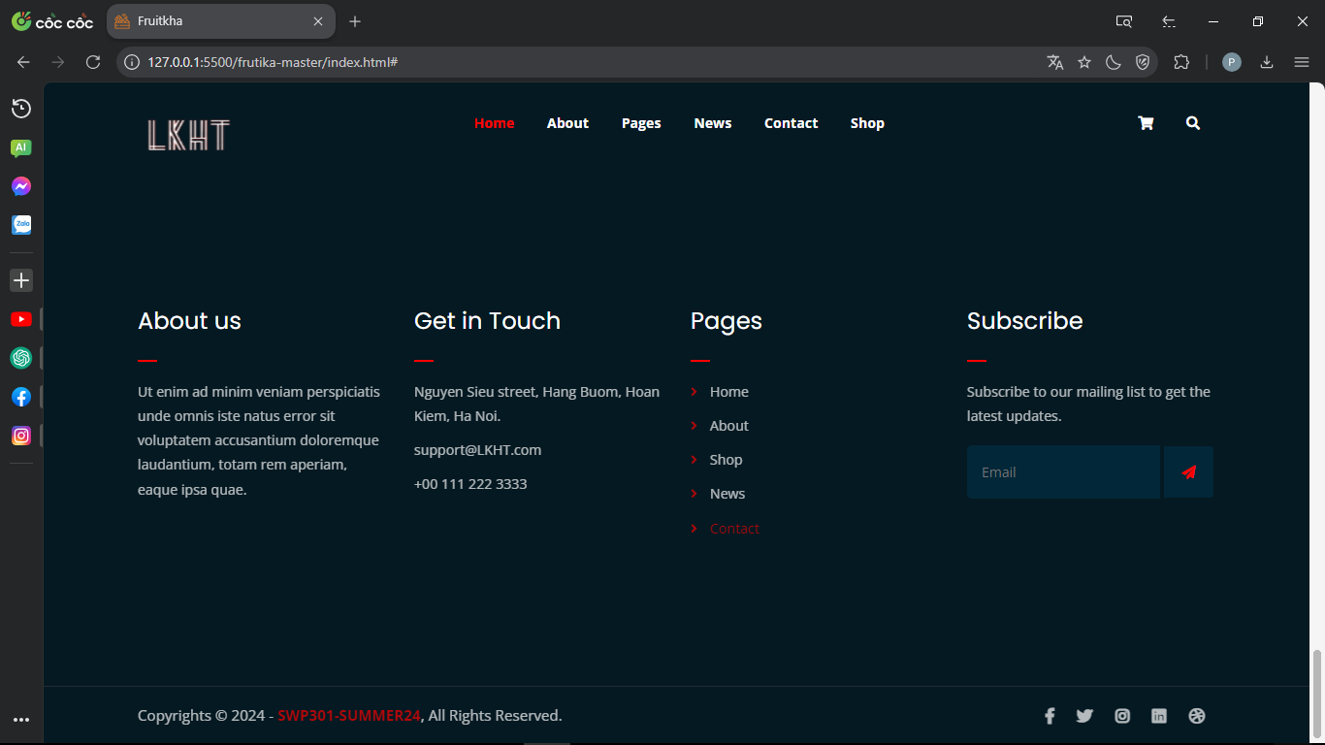

1. **Login**

